1. Create VPC

Name : webapp-vpc

IPv4 CIDR : 10.0.0.0/16

Keep other configurations as default.

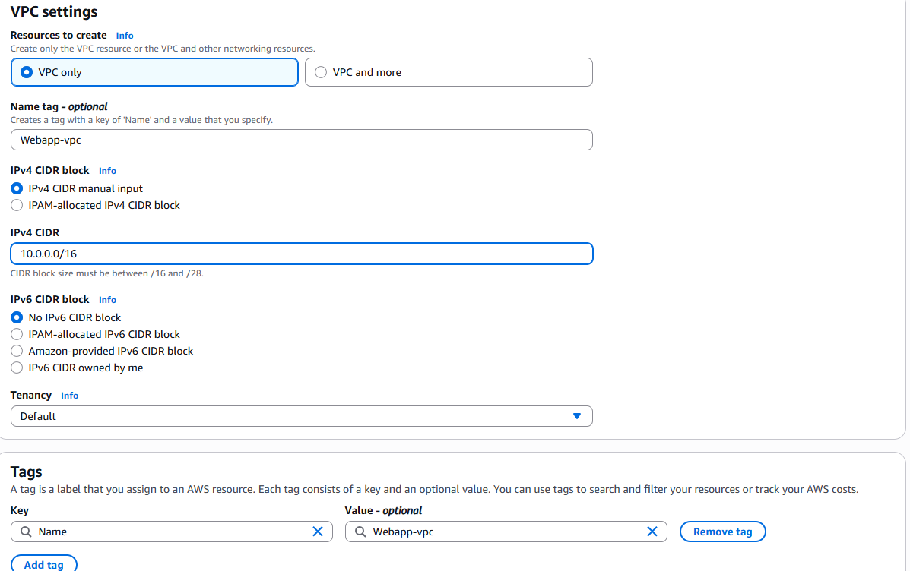

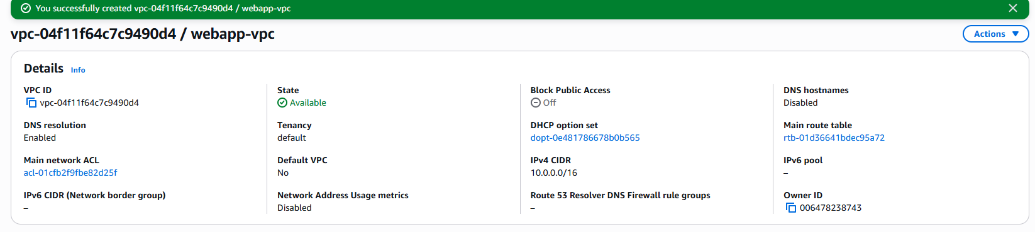

1. Create 2 subnets for vpc network.
2. Subnet 1 :

name : public-webapp-subnet

IP CIDR : 10.0.1.0/24

AZ : us-east-1a

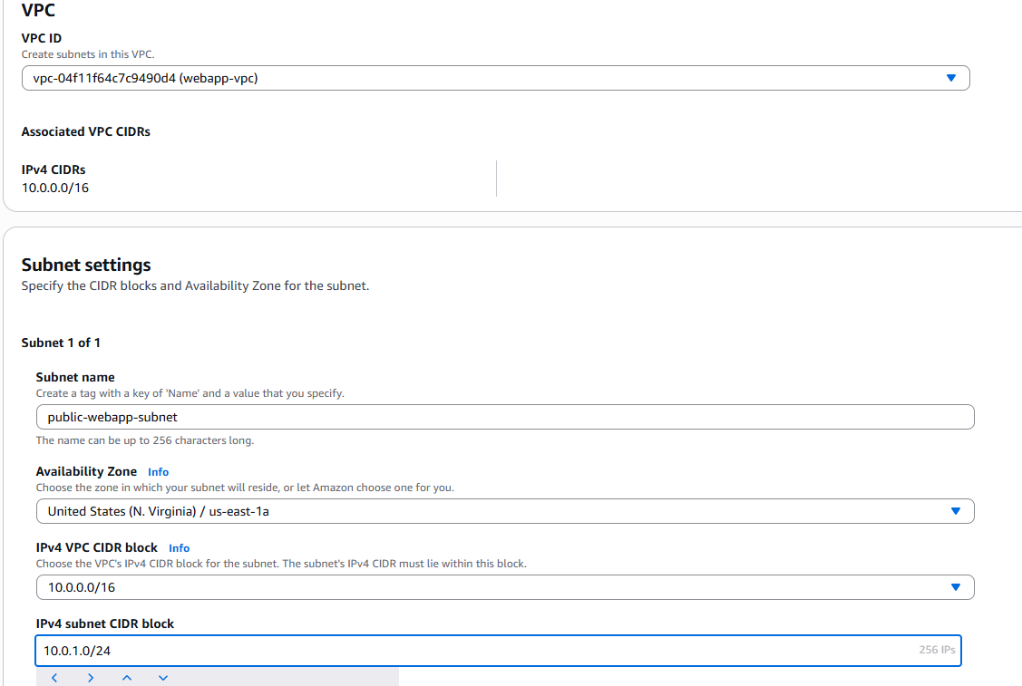

1. Subnet 2:

Name:private-webapp

IP CIDR:10.0.2.0/24

AZ:us-east-1a

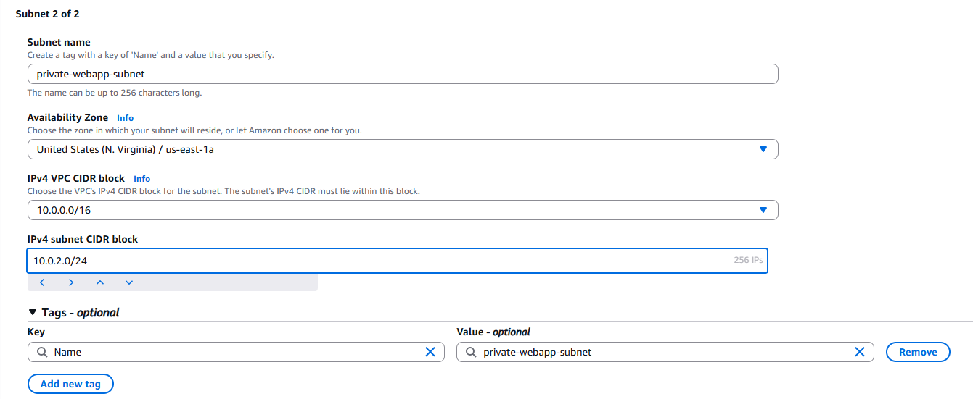

1. Create internet gateway. Name as “webapp-igw”.

Attach IGW to VPC.

1. Create route table.

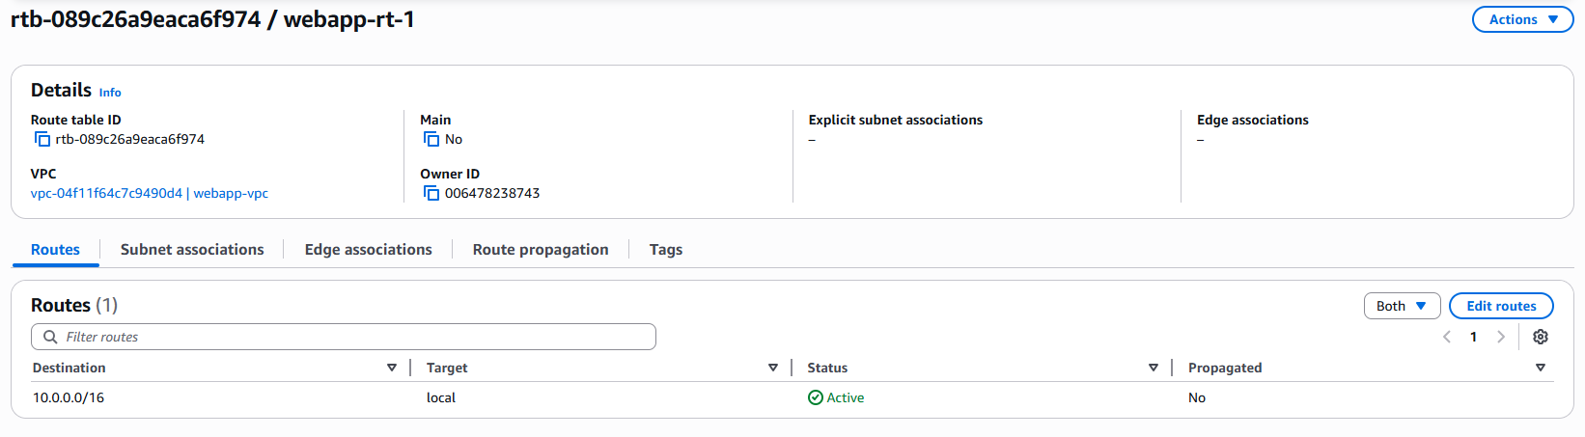

Associate subnet with route table.

Add route to internet gateway.

1. Create EC2 instance in public and private subnets.
2. Webserver instance in public subnet.

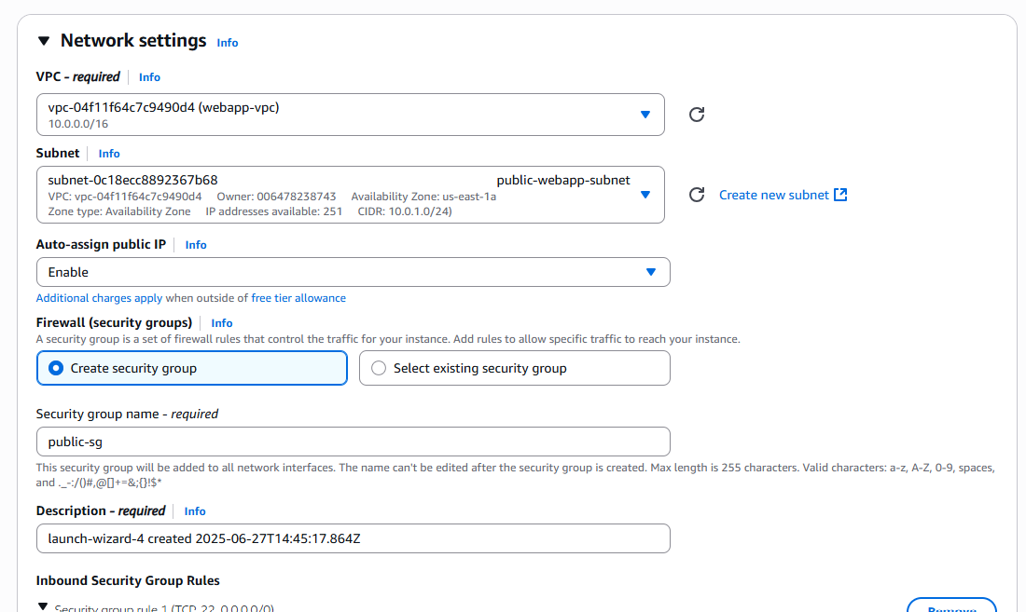

Connect to webserver-instance and try to install httpd.

1. Bastion server in public subnet.

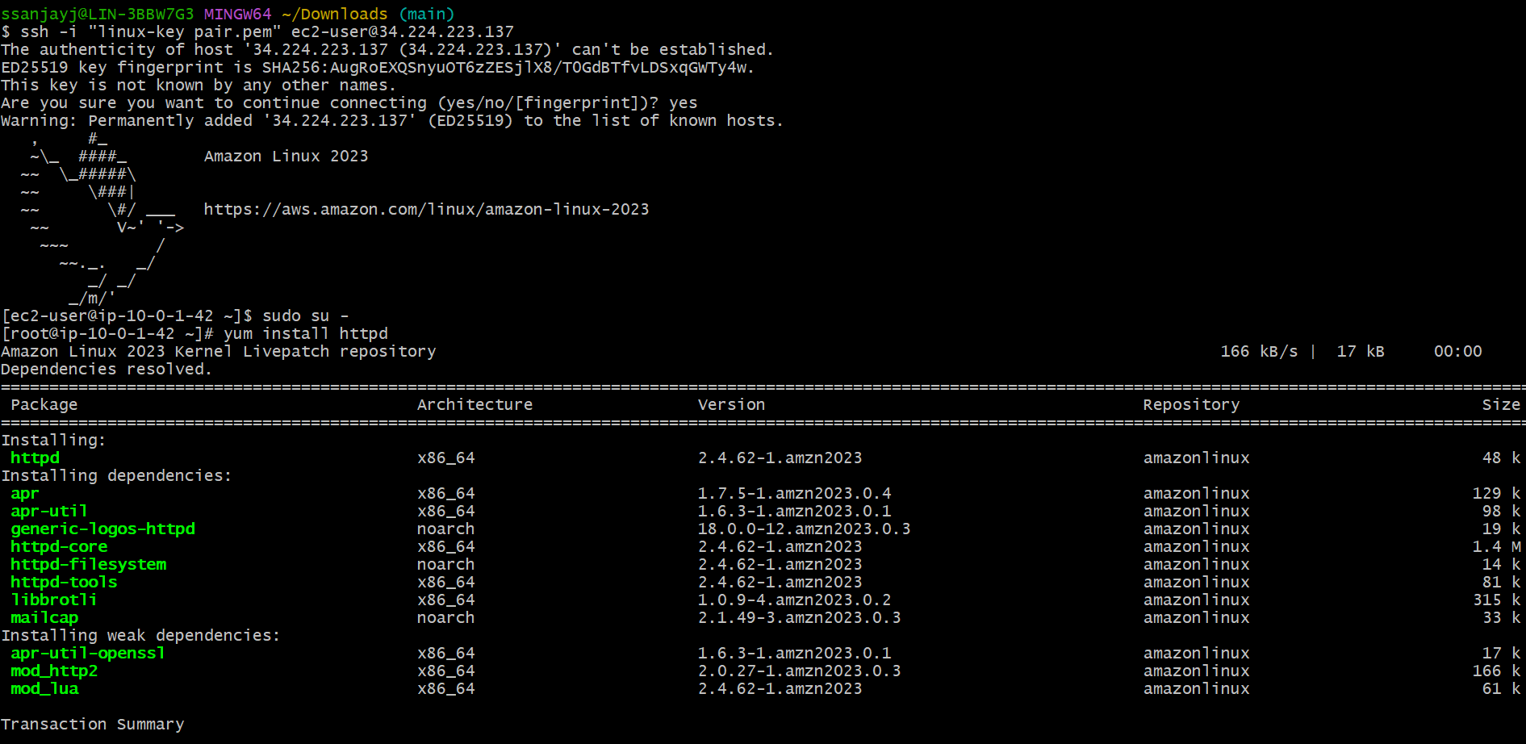

1. Database server in private subnet. Not able to access.

Access the database server from bastion server.

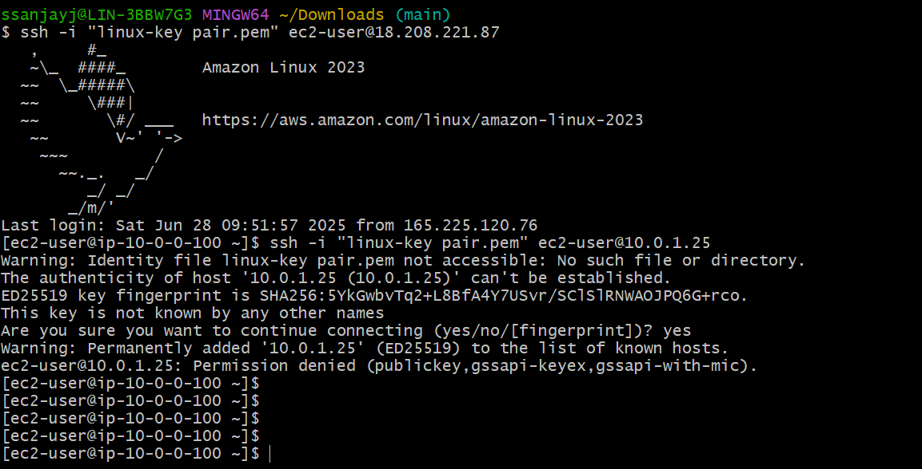

1. Create NAT gateway. Select private subnet.

1. Create route table.

Assoicate to private subnet.

Create route to nat gateway.

1. Able to install application in database server.

